22.3: a) Given thatL, and
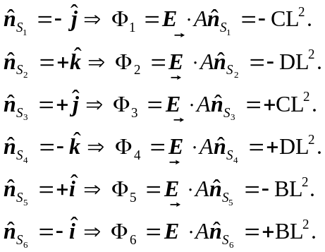
b) Total flux